# CS 340 README Lynn McCargar

*Use this template to complete your README file. When completing the template, keep the headings as they are so that your document has a clear organization. Remove the italicized prompt text after you have completed each section for a polished final document.*

## About the Project/Project Title

*The project is based on a client/server architecture that utilizes create, read, update, and delete (CRUD) for interacting with database. Some of the main operations a developer will need in order to programmatically work with databases involve CRUD methods. This project consist of a web front end client, with Python middle ware, and a MongoDB backend data source. This project is in the category of a full stack development applications, that exists within a client/server environment.*

## Motivation

*The motivation behind this project is to learn to develop full stack application in a client/server environment. Many companies need to ability to access their data through a web frontend. This project provides a mechanism to do such a task.*

## Getting Started

*The first step of the project is to import the AAC csv file into the Mongo database. Then you will create the admin account to administer the database. Next create the ‘aacuser’ user account to handle to day to day operations of the application.*

*Once the database environment is setup, we need to create an insert and query functions to manipulate the data. Some of the issues arouse around the authentication to the Mongo database. And getting around the Apporto thin client environment too.*

## Installation

*The MongoDB import tool is what was used to import the csv file into the Mongo database. Jupyter Notebook as an IDE to write the Python files. The Ubuntu Linux distr as the operating system for the project.*

*Import screenshot:  
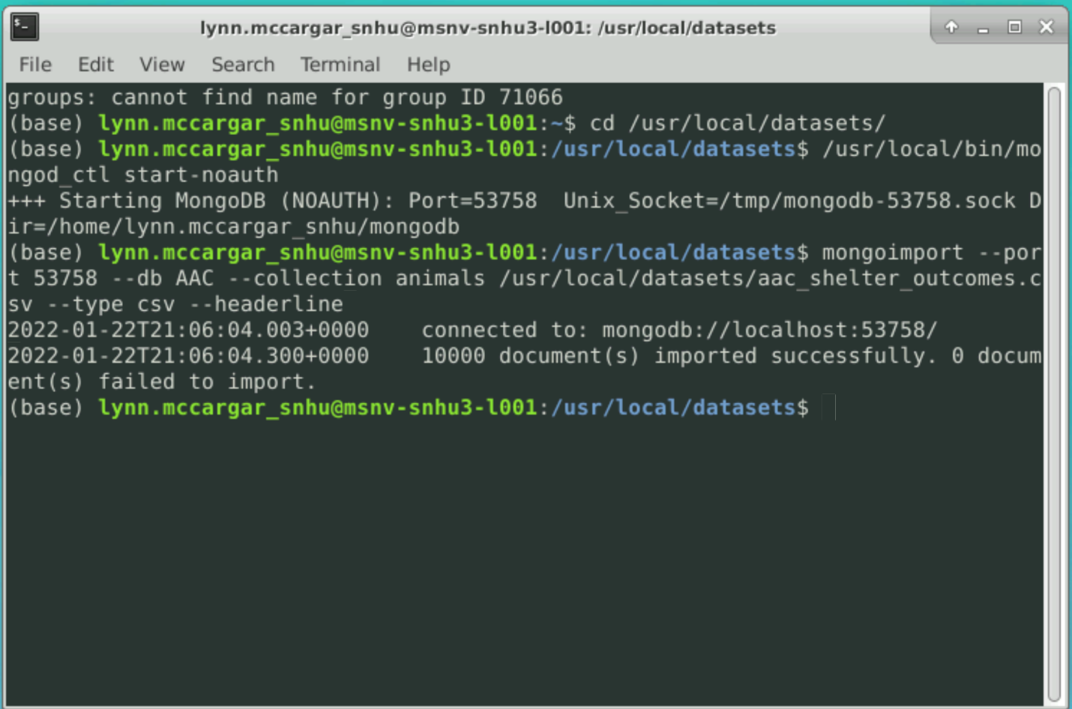*

*Admin and user accouts:  
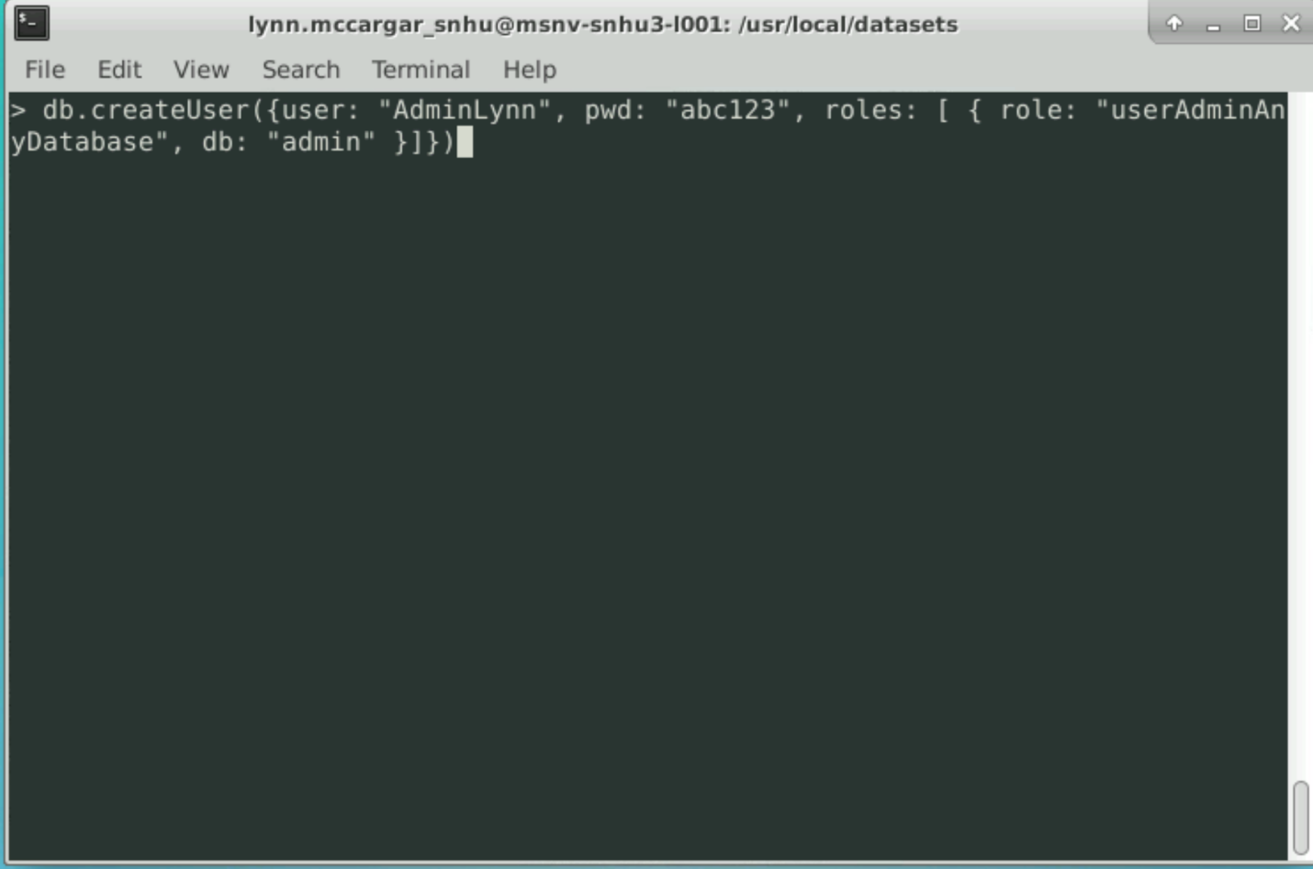*

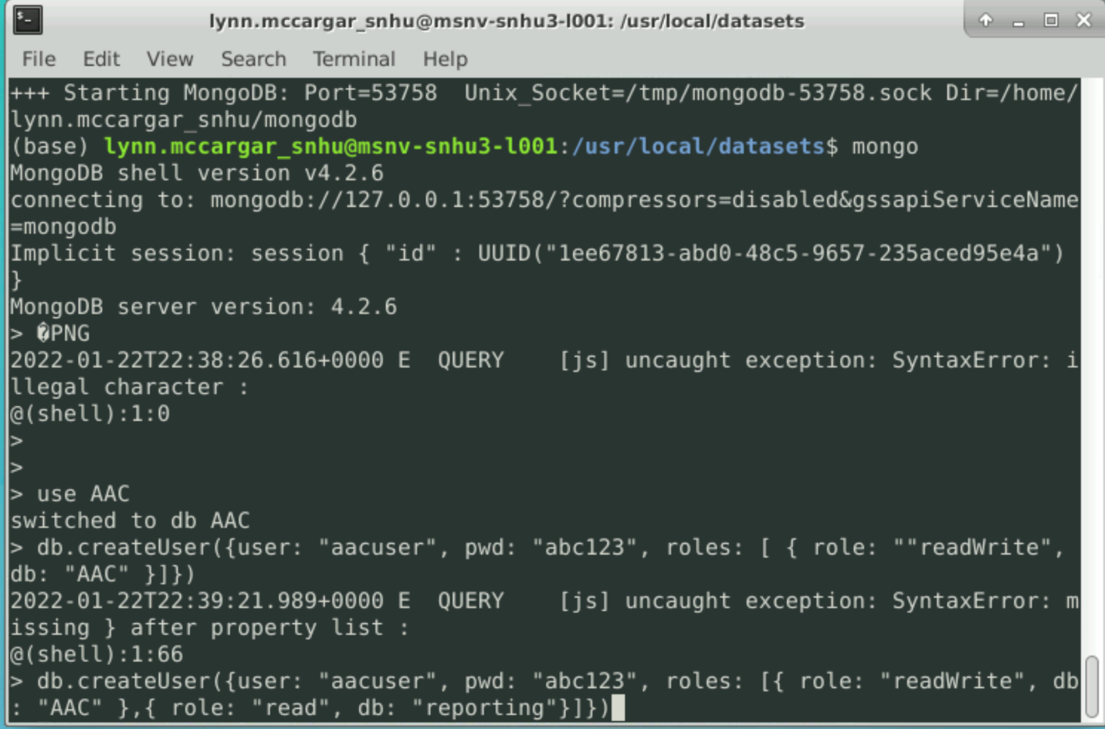

*Admin account validation:  
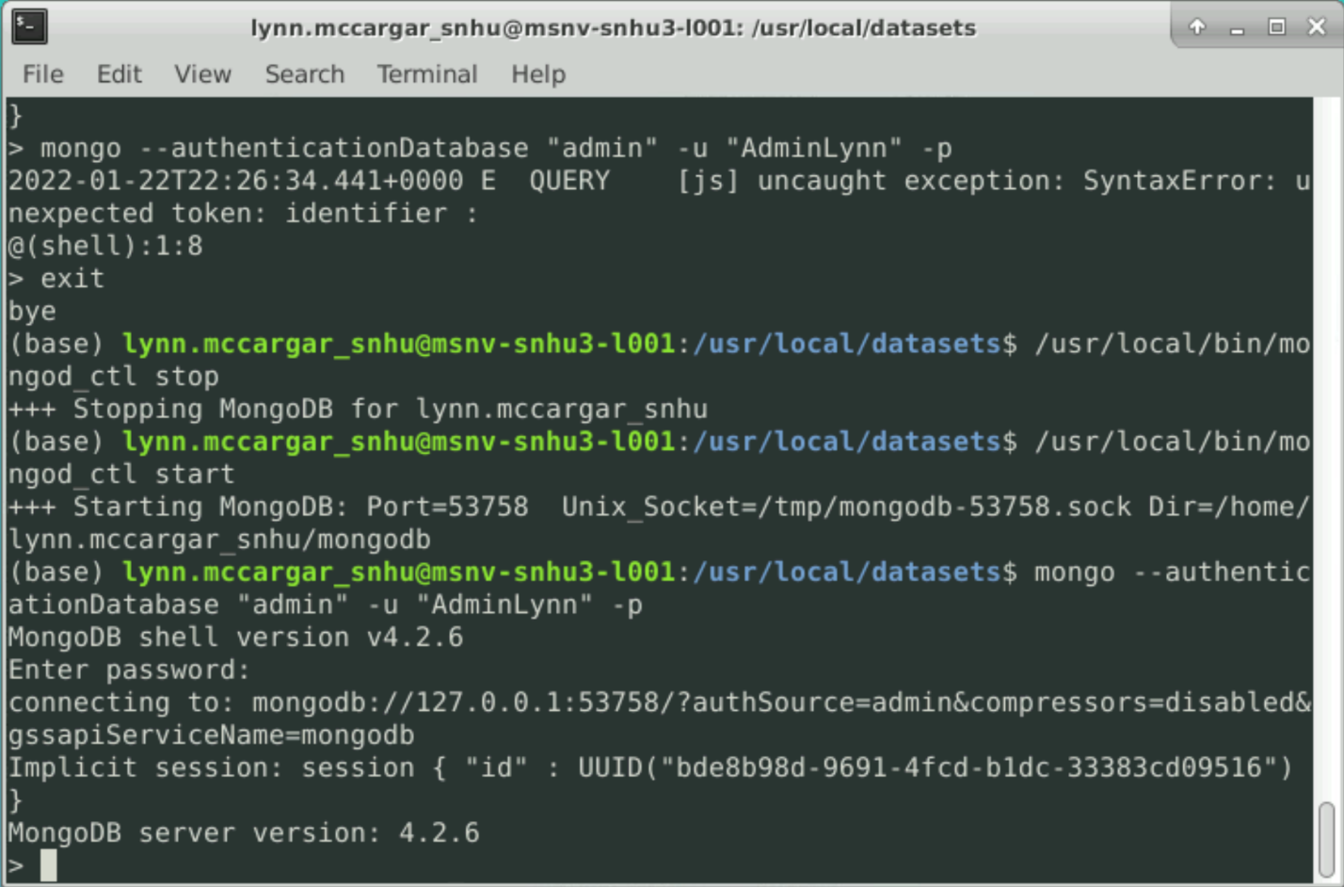*

*User account validation:  
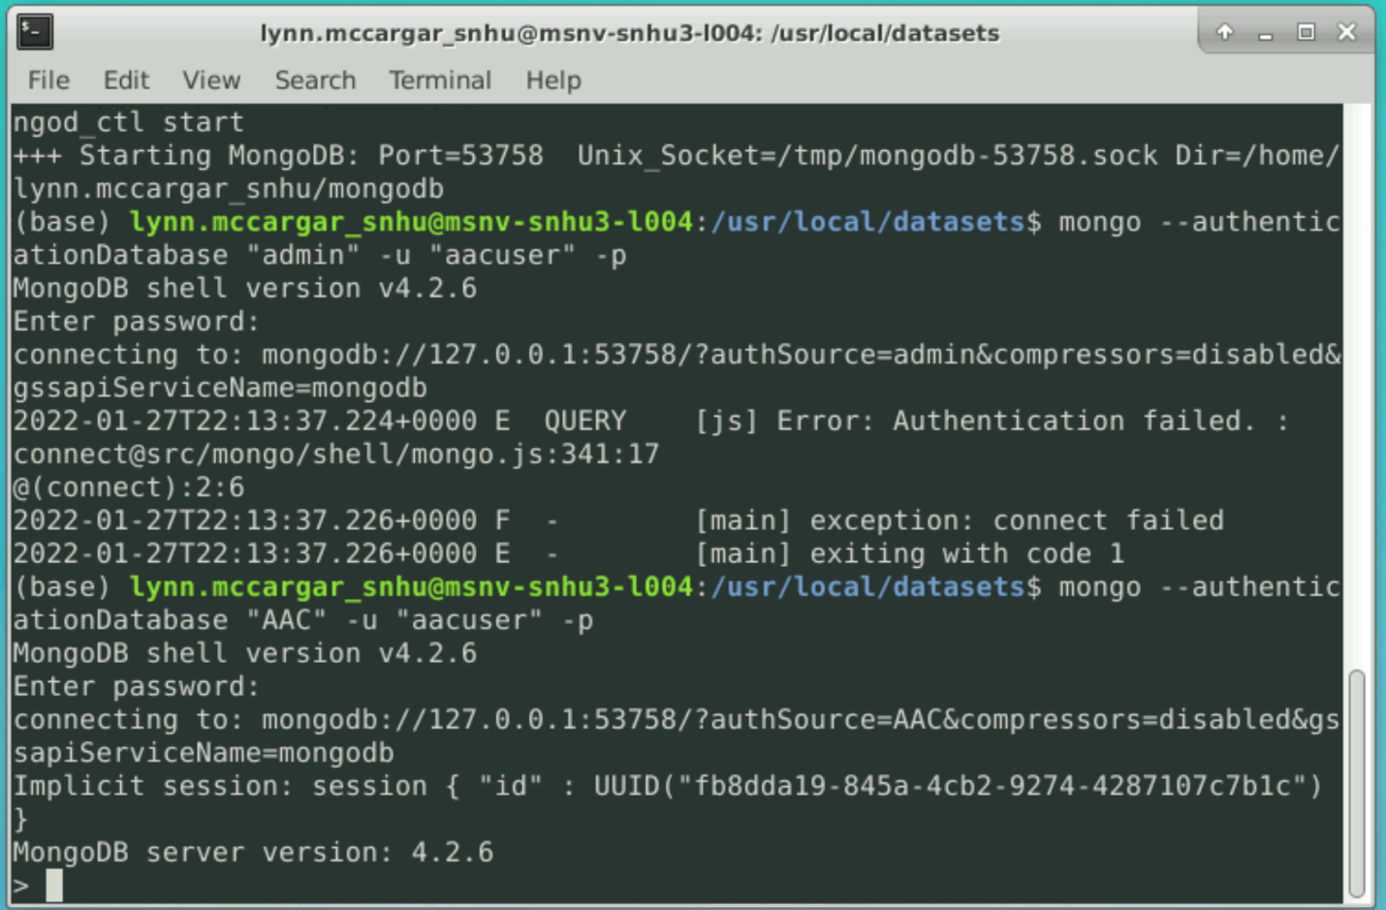*

## Usage

*Use this space to show useful examples of how your project works and how it can be used. Be sure to include examples of your code, tests, and screenshots.*

### Code Example

*# Complete this create method to implement the C in CRUD.*

*def create(self, data):*

*if data is not None:*

*if data:*

*self.database.animals.insert_one(data) #Check to see if there is data*

*return True*

*else:*

*return False*

*# Create method to implement the R in CRUD.*

*def read(self, search):*

*if search is not None:*

*if search:*

*searchResult = self.database.animals.find(search)*

*return searchResult*

*else:*

*exception = "Search parameter id empty"*

*return exception*

*# Method to implement the U in CRUD*

*def update(self, data):*

*if data is not None:*

*self.database.animals.save(data.get_as_json())*

*else:*

*updateException = "No results found"*

*return updateException*

*# Method to implement the D in CRUD*

*def delete(self, data):*

*if data is not None:*

*self.database.animals.remove(data.get_as_json())*

*else:*

*deleteException = "Nothing to delete"*

*return deleteException*

### Tests

*from animalShelter import AnimalShelter*

*# Define data*

*data = {"age_upon_outcome": "3 year",*

*"animal_id":"A746874","animal_type":"cat",*

*"breed":"Domestic Shorthair Mix", "color":"Black/White","date_of_birth":"2014-04-10",*

*"datetime":"2017-04-11 09:00:00", "monthyear":"2017-04-11T09:00:00","name":"",*

*"outcome_subtype":"SCRP", "outcome_type":"Transfer","sex_upon_outcome":"Neutered Male",*

*"location_lat": 30.5066578739455, "location_long": -97.3408780722188,*

*"age_upon_outcome_in_weeks": 156.76785714}*

*# Define search criteria*

*searchResult = {"animal_id":"A746874"}*

*# Search*

*assignment = AnimalShelter*

*# AnimalShelter object as assignment*

*assignment.__init__(assignment, "aacuser", "xyz123")*

*# Call to the constructor*

*success = assignment.create(assignment, data)*

*# Call to the create function*

*assert success == True*

*print(success)*

*# Print results of create method*

*results = assignment.read(assignment, searchResult)*

*# Call to the read function*

*print(results)*

*update_query = {'animal_id':'A746874'}*

*update_query_name = {'$set':{'name':'Rover'}}*

*result = assignment.update(update_query, update_query_name)*

*print(result)*

### Screenshots

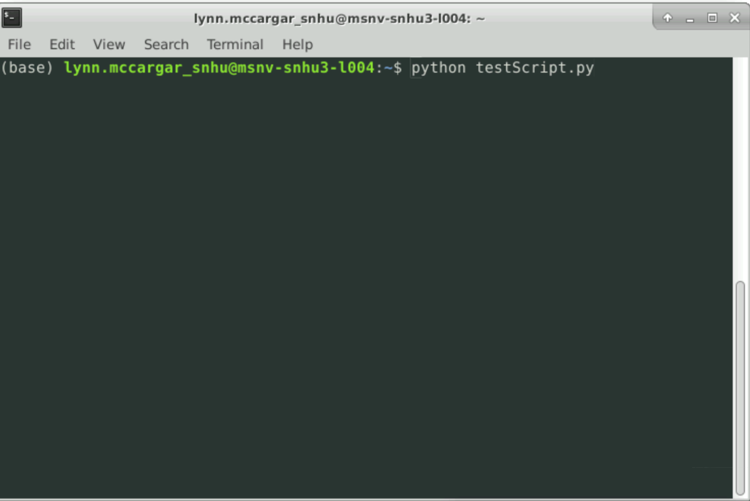

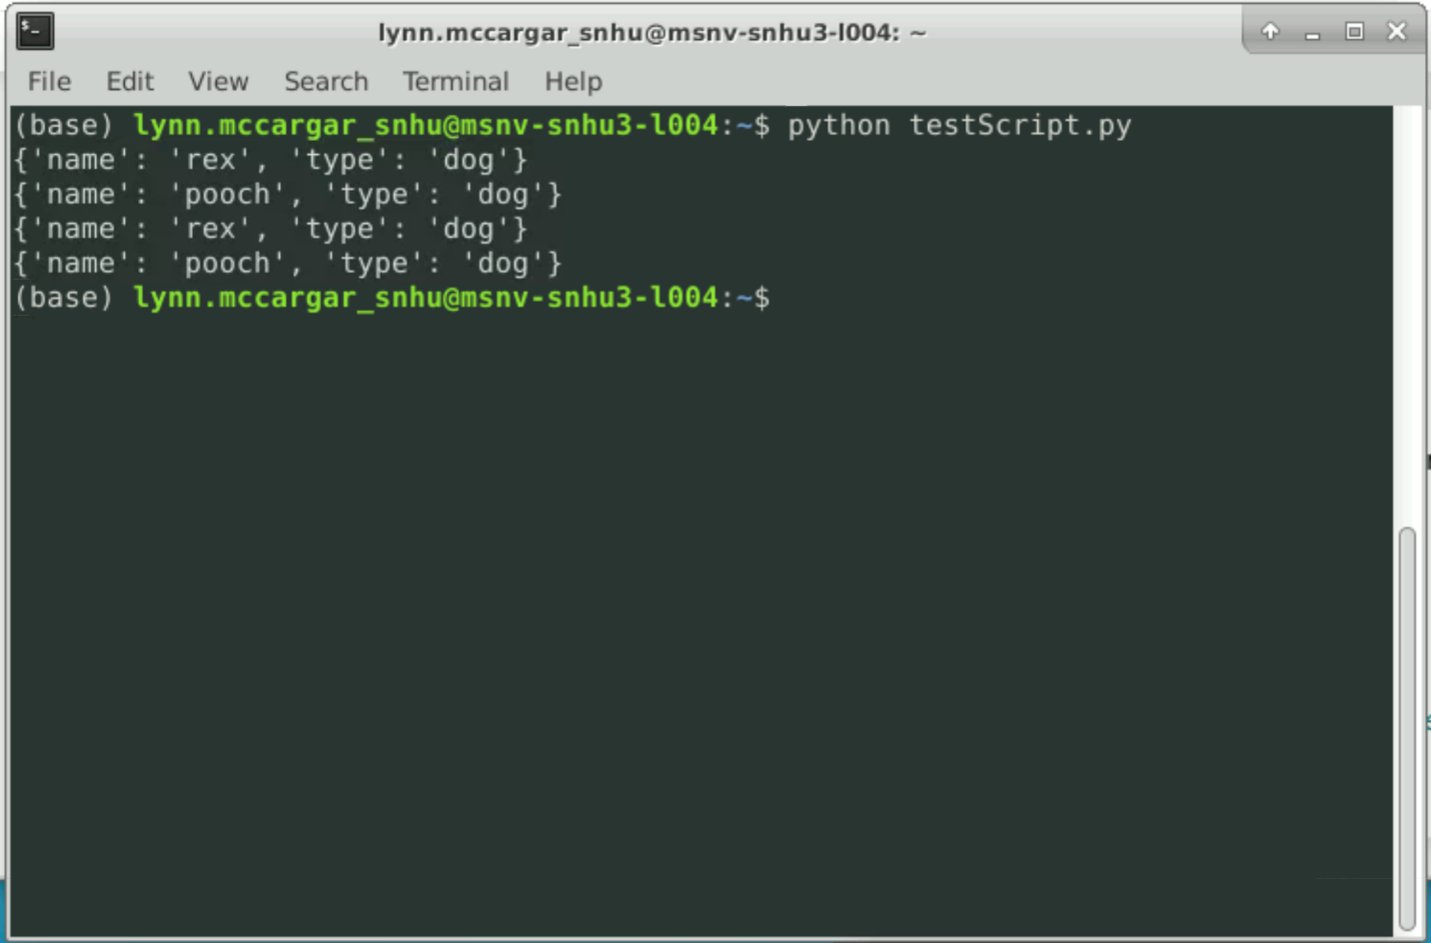

**Functionality**

*The client Grazioso Salvare had requirements to filter data based on the type of canine for certain human rescue events. With these requirements a dashboard full stack application tiers would need to provide the functionality for this customer. Below are images of the dashboard application in action:*

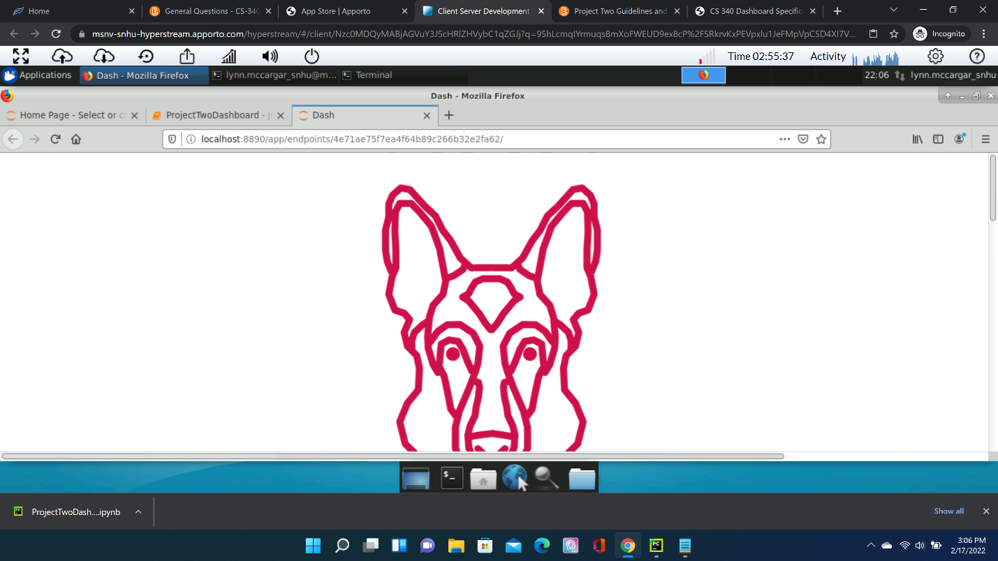

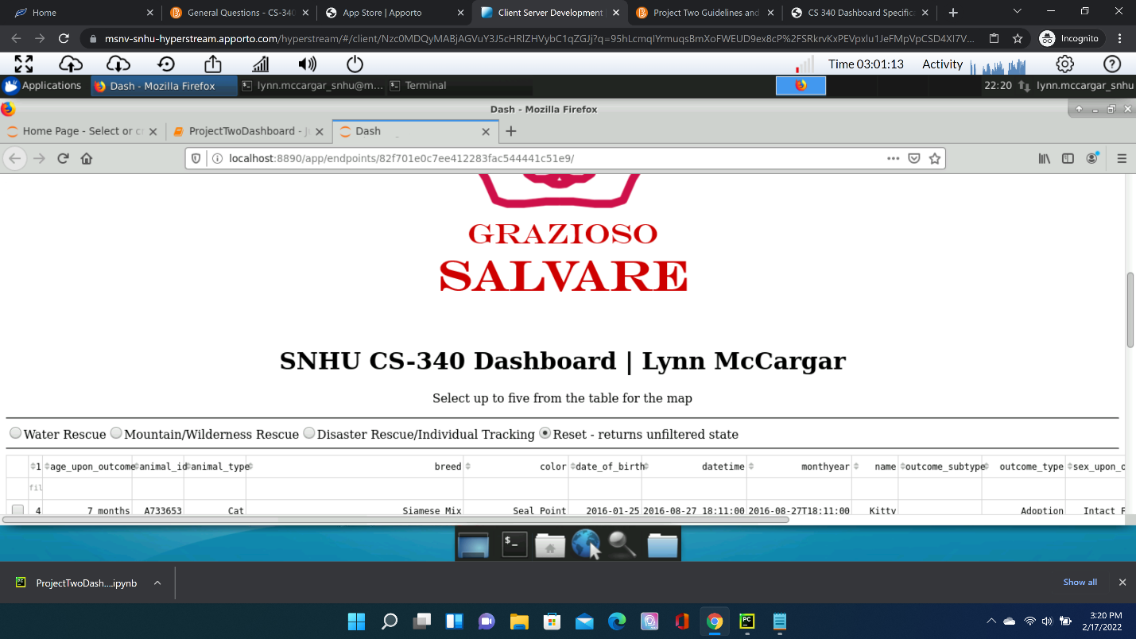

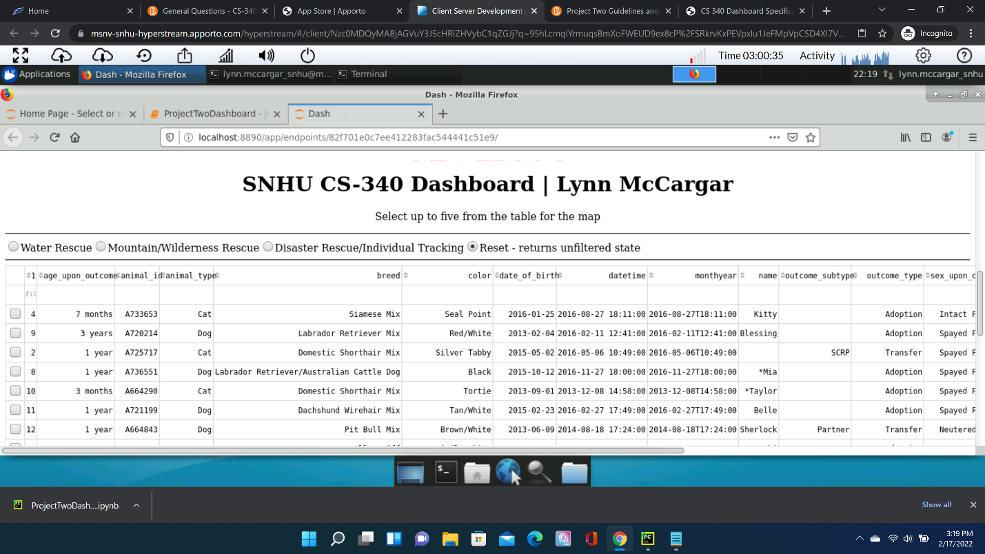

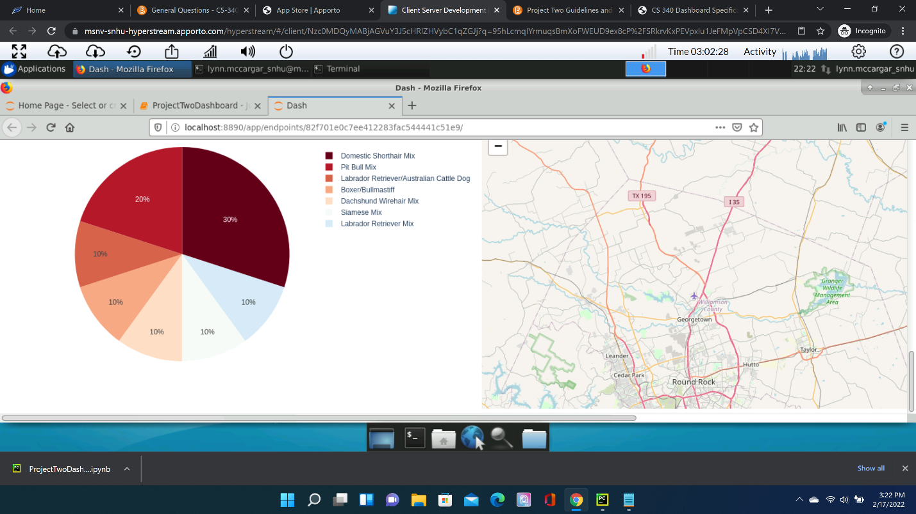

*The above screenshots represents unfiltered data of all the types of canines. Below is an example of the filtered type of canine for water rescues:  
   
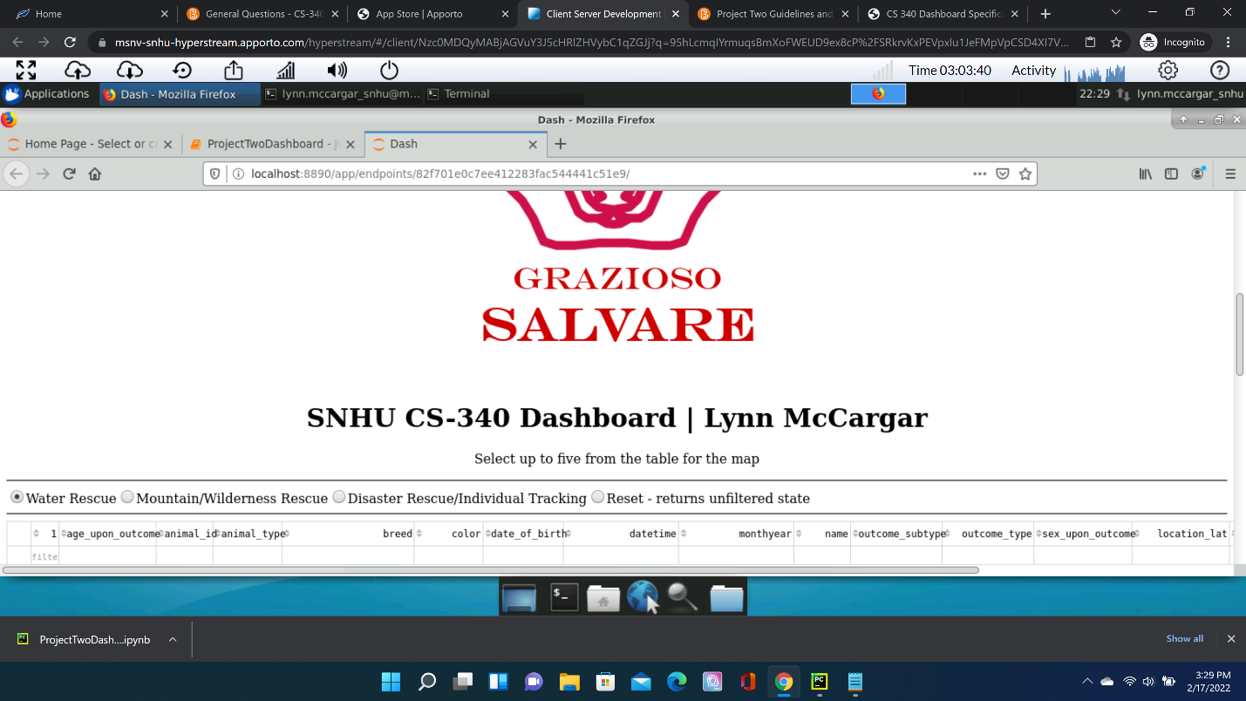  
  
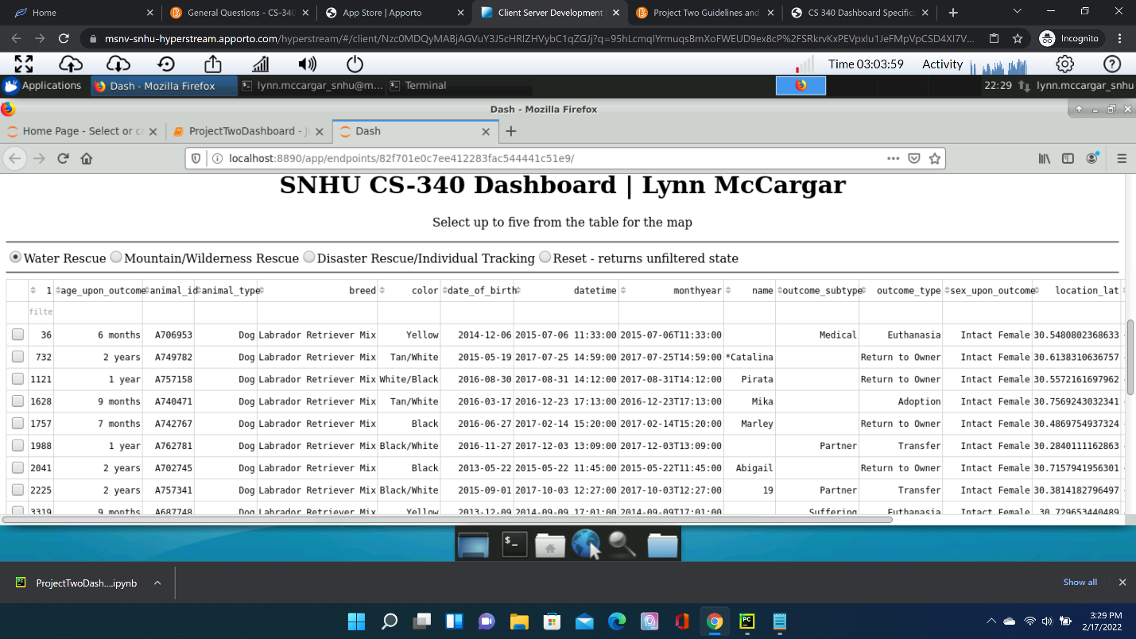*

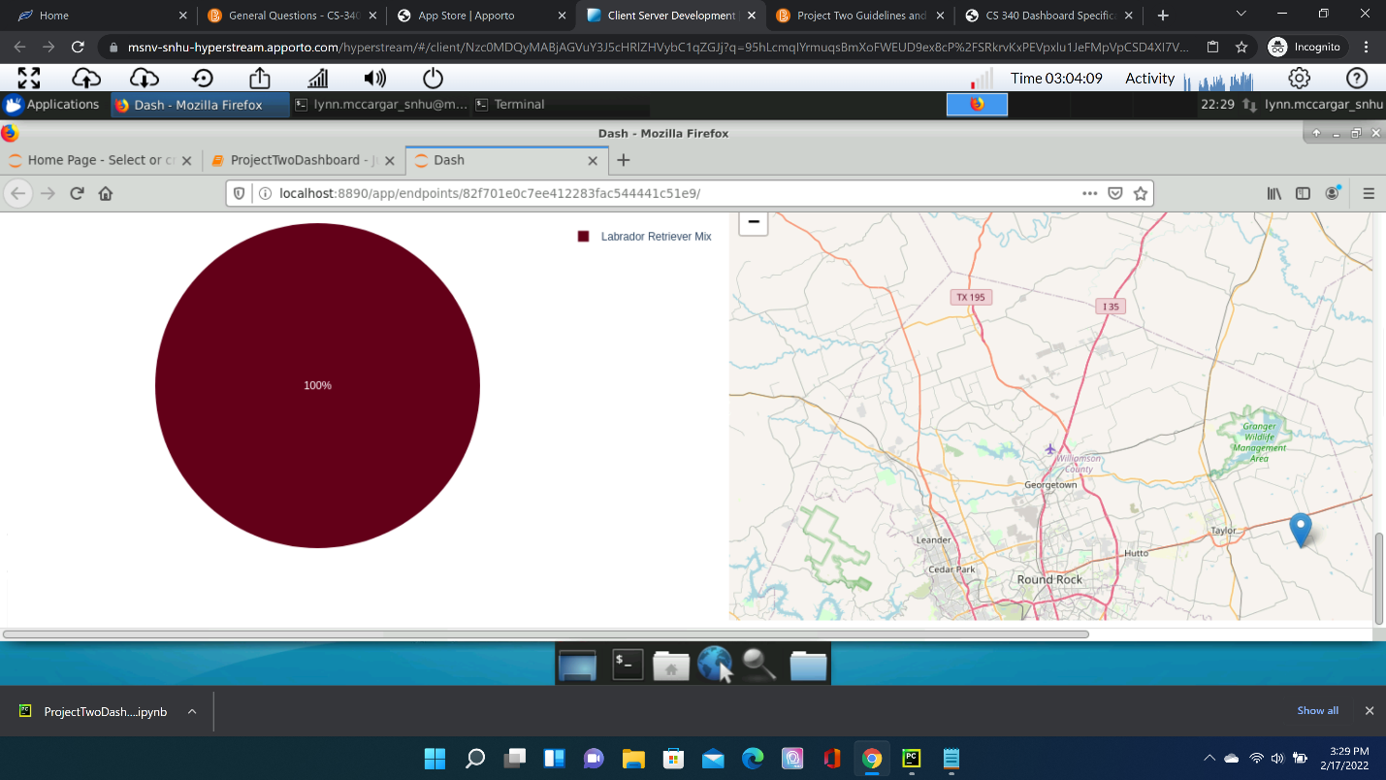

*Next is the filtered set for mountain/wilderness rescues:  
*

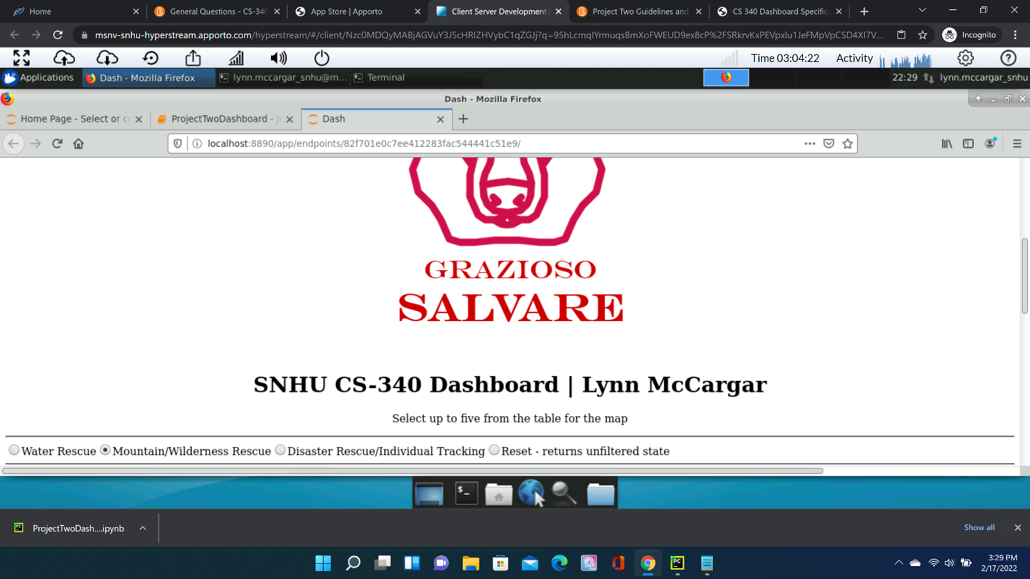

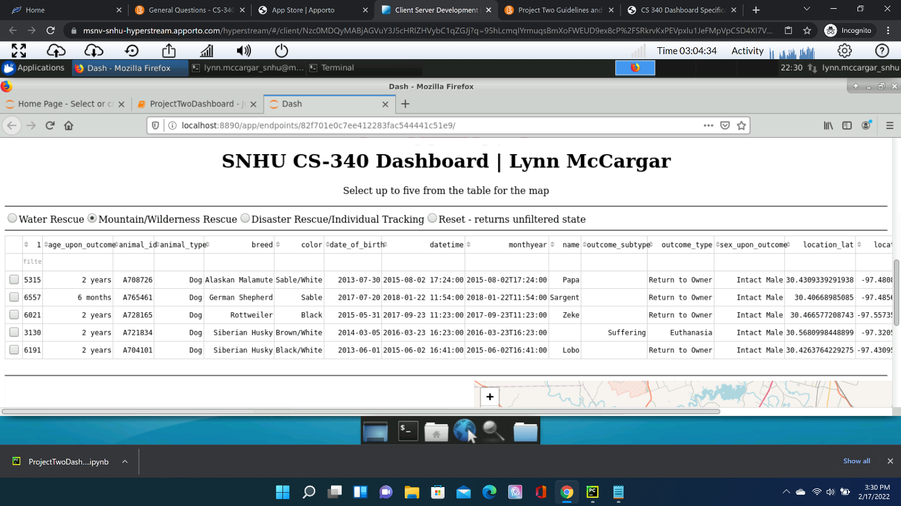

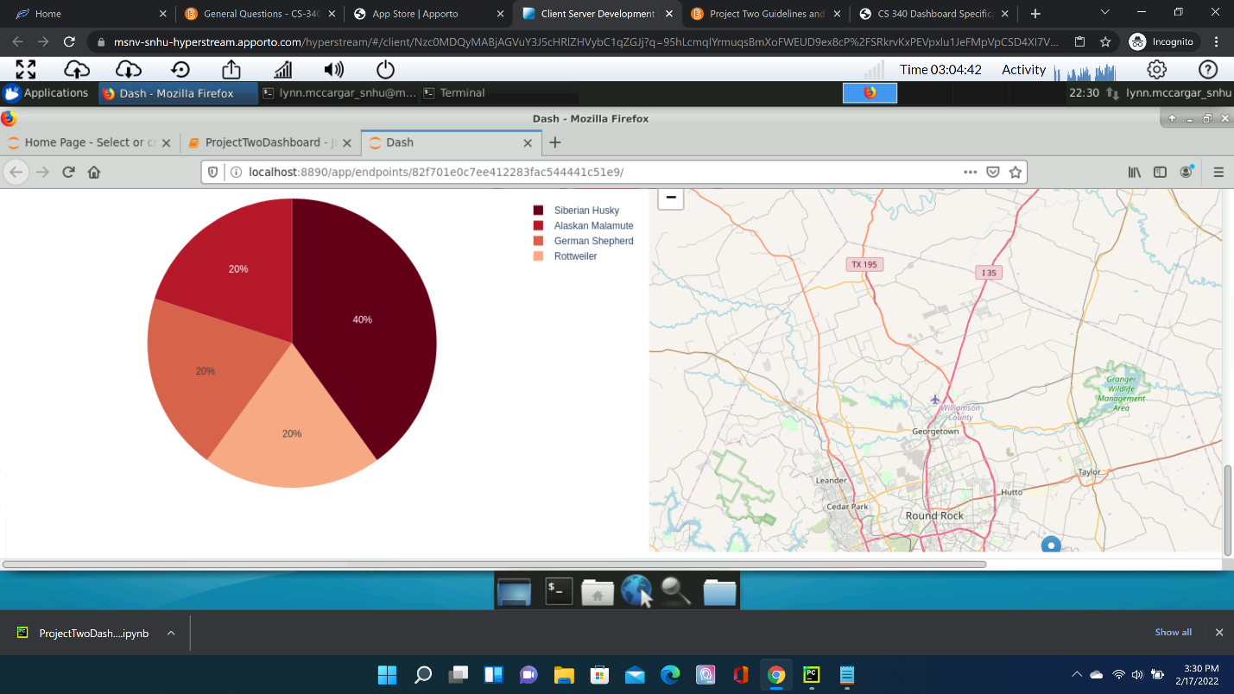

*Lastly, the next filtered data set is the disaster rescue/individual tracking:  
*

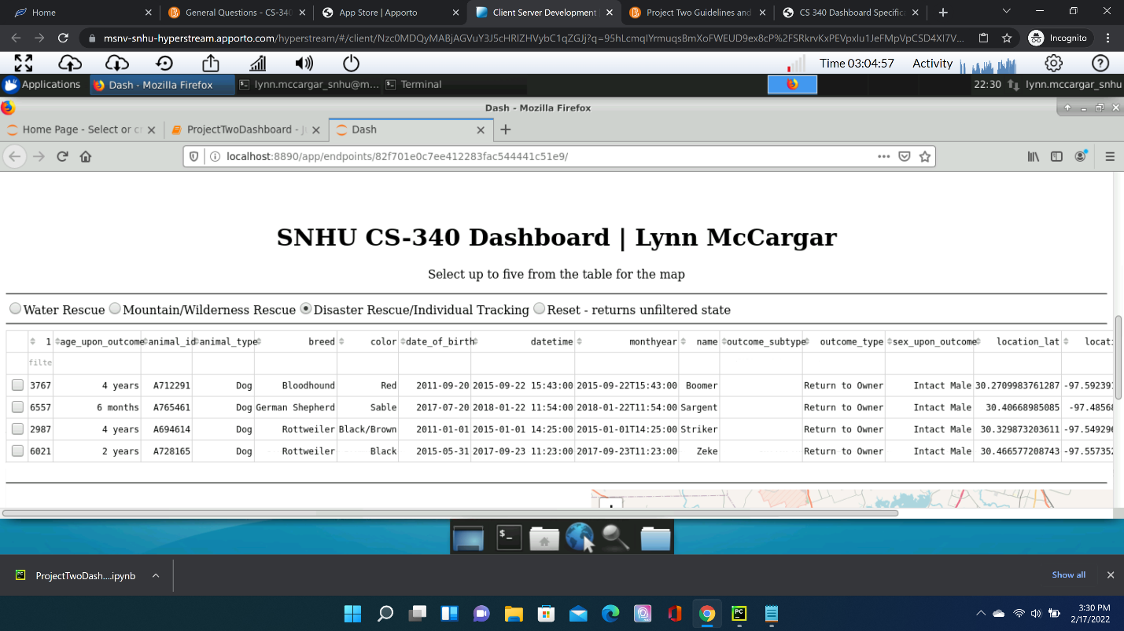

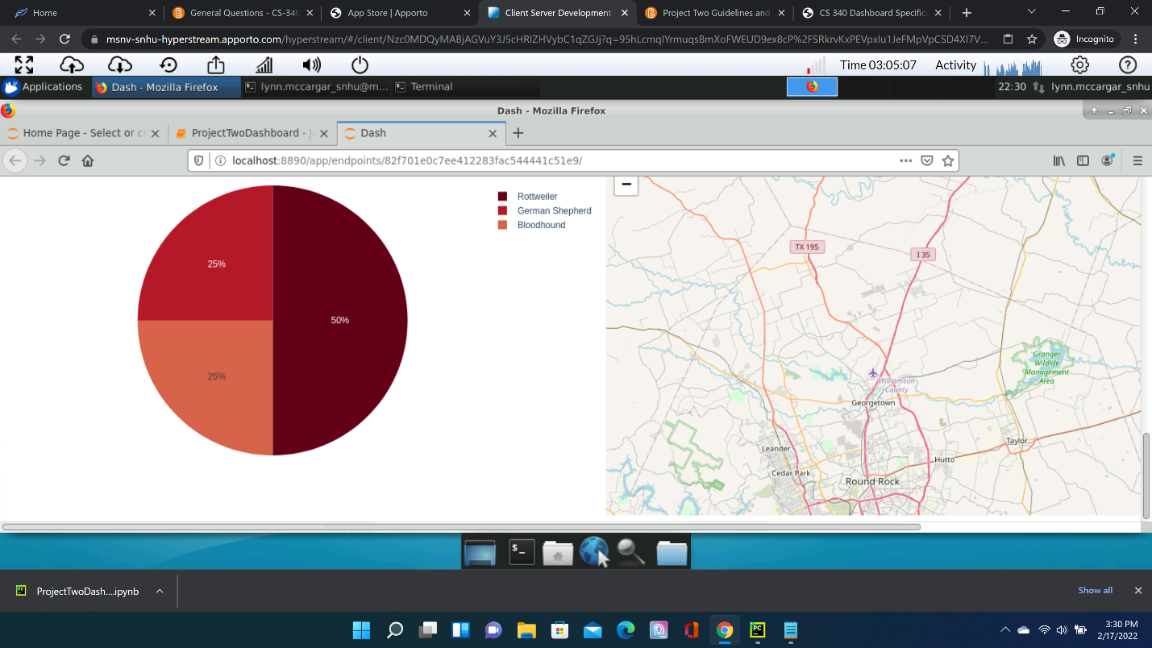

**Tools**

*The tools used to accomplish this project were Python language and MongoDB database. MongoDB is an open source document database, otherwise known as a No-SQL database. Python is an interpreted high level development language.*

*The AnimalShelter class is a custom module using Python and with two attributes: client and collection. The client attribute uses the MongoClient class imported from PyMongo library and receives an IP address with port of a database and the DB user credentials as constructor arguments.*

*The methods of AnimalShelter include: create(), find(), update, and delete(). The create() method collects a python dictionary as an argument and inserts it as a document in the animals collection. The find() method collects search criteria as an argument in the form of a python dictionary, then searches through the animals collection for the search criteria. The update() method takes two arguments: search criteria in the form of a dictionary and new values to update with. When the animals collection contains a document that matches the search criteria, the document’s contents are updated with the new values. The delete() method takes search criteria as an argument in the form of a dictionary and searches the animals collection for a match. When a match is found, the matching document is then deleted from the database.*

*The middleware is uses the Dash framework and Pandas dataframe for data analysis. The Dash framework is used for structuring web page components for the clientside dashboard. Inside the html divs are the Dash radio buttons, data table, pie chart, and map, all of which allow interactivity. A combination of Dash, Pandas, and core Python are used to implement the functionality of these dashboard components. Pandas dataframes are used to retrieve and filter the data from the database queries, while Dash callback functions provide a structure for making the components interactive.*

**The Process***The process to complete this project started with coding and testing the AnimalShelter class. This class used the CRUD methodologies in increments starting with the create and read functions of the class. Once the AnimalShelter class was tested and completed the project shifted to the dashboard build. The bulk of the dashboard development focused on the dashboard controller, layout, and views. The layout and views required using HTML code embedded in the dashboard. This was important for non-technical user friend filtering of the data. The interaction with the components and controller is the logic used for the filtering of the AAC dataset.*

**Issues**

*Much of the issues experienced during this project was due to inexperience with the MongoDB database and the Jupyter IDE. Doing research on these technologies helped overcome the inexperience issue. The instructor of this course filled in the knowledge needed to complete the project.*

## Contact

Your name: Lynn.McCargar@snhu.edu